Testing environment

🗂️ What Is Testing environment?
# Source: AI Source: Provided by: [Data Path: Persons Table -> ID Column: 1, Name_En Column: Motasem Essam] -> From: [ChatGPT] on [1/26/2026]
A testing environment is a setup where software is checked to make sure it works correctly, before it reaches the staging or production environment.
It acts as the application’s quality-check zone.
Purpose of a Testing Environment
It is used to:
- Verify that features work as expected
- Detect and fix bugs early
- Run automated and manual tests
- Ensure new changes do not break existing functionality

Typical characteristics
# Source: AI Source: Provided by: [Data Path: Persons Table -> ID Column: 1, Name_En Column: Motasem Essam] -> From: [ChatGPT] on [1/26/2026]
In a testing environment, you’ll usually see:
- 🧪 Automated tests (unit, integration, regression)
- 🗄️ Test databases with sample or mock data
- 🔐 Test credentials (never real user data)
- 🧾 Controlled logs (less noisy than development)
- 🚫 Limited external access
- ⚙️ Configuration close to production

Example configuration
# Source: AI Source: Provided by: [Data Path: Persons Table -> ID Column: 1, Name_En Column: Motasem Essam] -> From: [ChatGPT] on [1/26/2026]
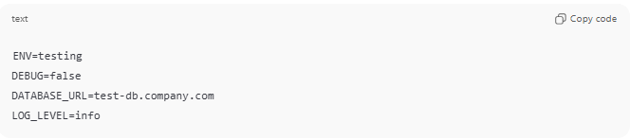
ENV=testing
DEBUG=false
DATABASE_URL=test-db.company.com
LOG_LEVEL=info

Who uses it
# Source: AI Source: Provided by: [Data Path: Persons Table -> ID Column: 1, Name_En Column: Motasem Essam] -> From: [ChatGPT] on [1/26/2026]
- QA engineers
- Developers (for validation)
- CI/CD pipelines (automatic testing on every change)
How it fits in the flow
# Source: AI Source: Provided by: [Data Path: Persons Table -> ID Column: 1, Name_En Column: Motasem Essam] -> From: [ChatGPT] on [1/26/2026]
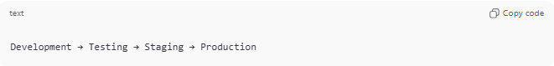
Development → Testing → Staging → Production

Development vs Testing
# Source: AI Source: Provided by: [Data Path: Persons Table -> ID Column: 1, Name_En Column: Motasem Essam] -> From: [ChatGPT] on [1/26/2026]
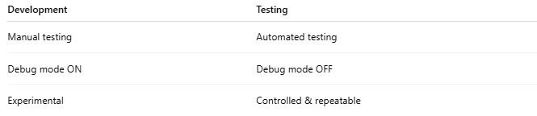
Development | Testing
Manual testing | Automated testing
Debug mode ON | Debug mode OFF
Experimental | Controlled & repeatable

Real-world analogy
# Source: AI Source: Provided by: [Data Path: Persons Table -> ID Column: 1, Name_En Column: Motasem Essam] -> From: [ChatGPT] on [1/26/2026]
Think of it like:
A test drive track for cars
Same car, safe track, controlled conditions.

